**Name:** V Venkata Sri Prasad

**Batch:** Data Engineering

**Date:** 12/02/2024 – (Day 18)

Topics:

1. Azure basic and workspace and cluster creation

**Azure Databricks creation:**

**Databricks Workspace Creation:**

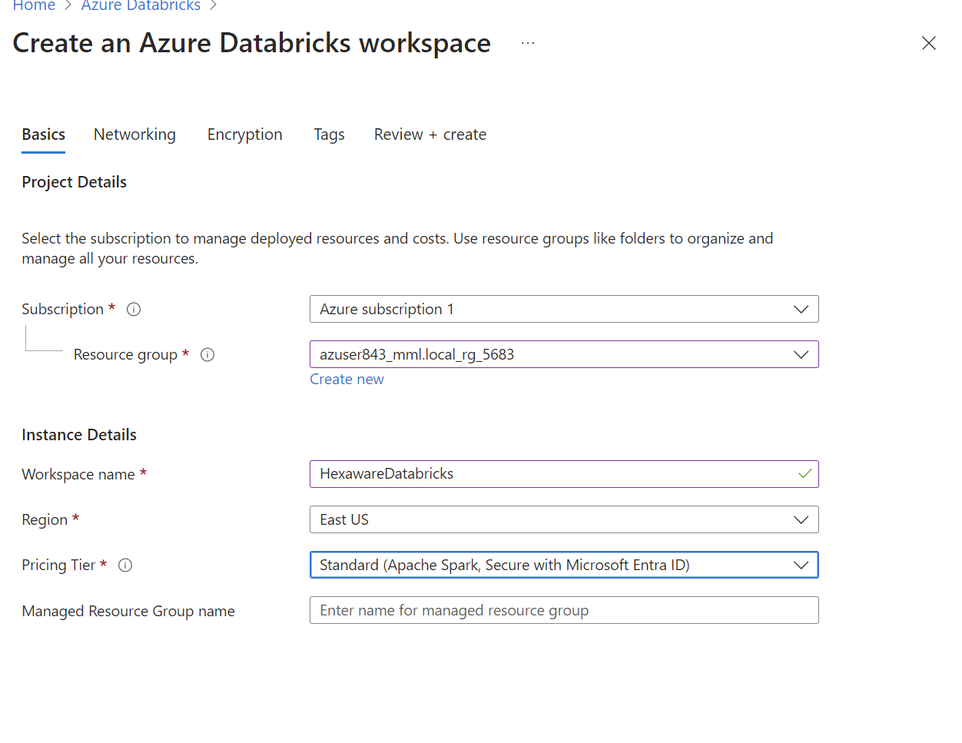

**Cluster Creation** ( Apologies mam , I have deleted my cluster so I’m pasting the reference image here)

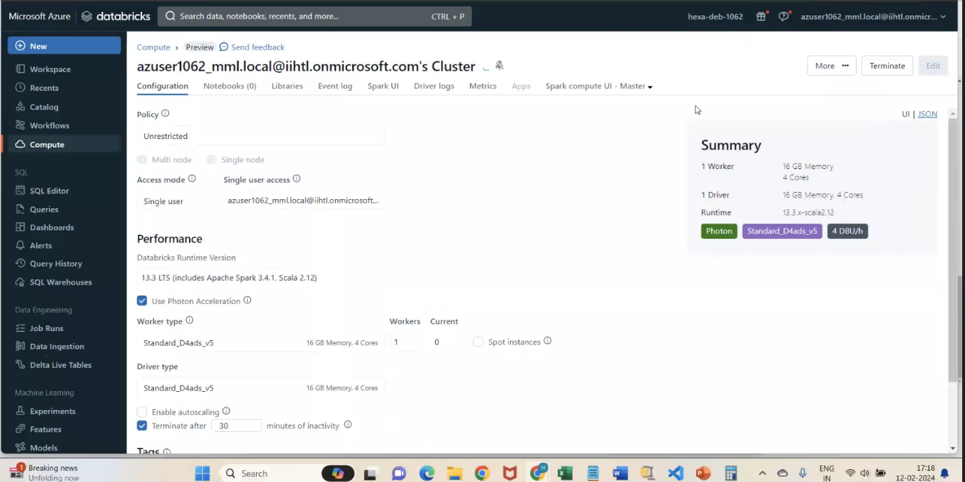

Notes:

